VIET NAM NATIONAL UNIVERSITY HO CHI MINH CITY
UNIVERSITY OF SCIENCE

Performance Testing: K6 vs. JMeter

Thực hiện:
Đỗ Huỳnh Diễm Uyên - 22125117 Phạm Ngọc Phương Uyên - 22125118
Trịnh Nguyễn Thảo Vi - 22125120
Huỳnh Phan Nhật Vy - 22125124

Table of Contents
I. Overview of performance testing 3
1.1. What is Performance Testing? 3
1.2. Who benefits from Performance Testing? 3
II. Importance of performance 4
2.1. Why do we need Performance Testing? 4
2.1. Key Benefits 4
III. Methodology and process 5
3.1 Performance Testing Metrics 5
3.2. How many types of Performance Testing? 6
3.3. Difference between Load Test, Stress Test, and Spike Test 7
3.4. Steps of performance testing 8
IV. Demo Tools: 9
4.1. JMeter 9
4.1.1 What is JMeter 9
4.1.2 Apache JMeter Features 9
4.1.3 Advantages JMeter 10
4.1.4 Disadvantages JMeter 10
4.1.5 Configure scenario 10
4.2. K6 12
4.2.1 What is K6 12
4.2.2 K6 Features 12
4.2.3 Advantages K6 13
4.2.4 Disadvantages K6 14
4.2.5 Implement scenario 14
V. Reference 16

Overview of performance testing

1.1. What is Performance Testing?
Software performance testing is a non-functional software testing technique that determines how the stability, speed, scalability, and responsiveness of an application holds up under a given workload.

The goals of performance testing include evaluating application output, processing speed, data transfer velocity, network bandwidth usage, maximum concurrent users, memory utilization, workload efficiency, and command response times.

1.2. Who benefits from Performance Testing?
Developers use performance testing to find performance issues early in the software development lifecycle (SDLC) so they can prioritize development changes and enact them more efficiently.

QA teams rely on performance testing to inform their efforts and help them determine whether an application’s operating speed, functional stability and scalability features are working sufficiently at various workloads.

DevOps crews operating within the continuous integration and constant delivery (CD/CD) pipeline can incorporate performance testing to automatically verify that each developer change doesn’t degrade system behavior.

Project managers use performance testing to assess risks and gauge system impacts that could result from system changes.

Chief technology officers (CTOs) or staffers in similar capacities need performance testing to help them determine how shifting demands can be translated into long-term growth.

Company owners are all about protecting revenue streams. Performance testing confirms that load times are sufficiently quick and unresponsive customer service doesn’t trip up the revenue process.

Large businesses that regularly experience periods of high traffic volume depend on performance testing to confirm that their applications can handle heavy workloads. This approach is especially important for companies that are heavily reliant on online platforms with large user bases.

Small companies (and startups) need performance testing as part of growth-planning efforts. These organizations use performance testing to alert them about future bottlenecks that could negatively impact their ability to grow successfully.

Businesses (of any size) that are preparing to launch new applications are smart to engage in performance testing as a means of predicting problems with real-world operating scenarios. The same holds true for companies making important IT system changes.

Financial institutions hold enormous responsibility and face considerable industry regulations. Such businesses routinely use performance testing to help them maintain baseline standards, especially as they pertain to periods of high transaction volume

Importance of performance

2.1. Why do we need Performance Testing?
Organizations run performance testing for at least one of the following reasons:
- To determine whether the application satisfies performance requirements (for instance, the system should handle up to 1,000 concurrent users).
- To locate computing bottlenecks within an application.
- To establish whether the performance levels claimed by a software vendor are indeed true.
- To compare two or more systems and identify the one that performs best.
- To measure stability under peak traffic events.

2.1. Key Benefits
Enhances user experience: Users today have zero tolerance for slow or unresponsive applications. In fact, even a minor delay can lead to abandonment, lost revenue, and damaged reputations. According to Shopify, fast-loading pages that take less than three seconds to load have an average bounce rate of 8%. Performance testing ensures that your application delivers fast and efficient user experiences by identifying bottlenecks and optimizing response times. Smooth performance builds customer trust and loyalty, whether users browse a website, stream content, or use a mobile app.

Prevents downtime: Downtime can be catastrophic for businesses. A single crash during peak periods can result in lost transactions, frustrated users, and significant financial losses.

- Example: Imagine an e-commerce site crashing during a Black Friday sale. Beyond the immediate revenue loss, customers may never return.

Performance testing helps identify potential failure points and optimize system resources, ensuring your application remains resilient under extreme pressure.

Supports scalability: As your user base grows, your application must grow with it. Scalability testing helps ensure your system can handle increasing demands without compromising performance.
- Example: An online streaming platform may experience a spike in traffic when a highly anticipated show debuts. With proper scalability testing, the platform might succeed under the load.
- Why it matters: By simulating future growth scenarios, businesses can plan resource allocation effectively and prepare for unexpected surges in traffic.

Improves system reliability: Reliability is a hallmark of a great application. Stress and endurance testing uncover vulnerabilities that might cause crashes, slowdowns, or errors under heavy load.
- Example: A banking application processing transactions 24/7 must remain operational without hiccups, especially during tax season or end-of-month reporting.
- Why it matters: Performance testing ensures systems are reliable under normal and extreme conditions, minimizing disruptions and building user confidence.

Reduces costs: Fixing performance issues post-deployment is costly and time-consuming. Performance testing helps businesses save time, money, and resources by identifying and addressing problems early in the development lifecycle. According to IBM, fixing a defect post-release costs 4-5 times more than identifying it during development.

Ensures compliance: In finance, healthcare, and government industries, regulatory requirements demand strict adherence to performance standards. Performance testing ensures that your application complies with these regulations and avoids penalties.

Methodology and process

3.1 Performance Testing Metrics
- CPU utilization – percentage of CPU capacity utilized
- Memory utilization – utilization of the primary memory
- Response times – time between sending request and receiving response
- Average load time – time to complete the loading process
- Throughput – the number of transactions can be handled in a second
- Average latency/Wait time – the time spent by a request in a queue before getting processed
- Bandwidth – the volume of data transferred per second
- Requests per second – the number of requests handled per second
- Error rate – the percentage of requests resulting in errors
- Transactions Passed/Failed – the percentage of passed/failed transactions

3.2. How many types of Performance Testing?
Load testing: Load testing simulates the expected number of users or transactions to assess the system’s behavior under normal conditions. It measures how the application handles concurrent user traffic and transaction loads during peak usage.
- Example: An e-commerce platform must ensure smooth checkout even when hundreds of users shop during a Black Friday sale.
- Why it matters: Load testing ensures critical functionalities, such as database queries and server responses, meet performance benchmarks.

Stress testing: Stress testing pushes the system beyond its normal operational limits. It reveals how the system behaves under extreme conditions, such as unusually high user traffic.
- Example: A ticket booking website for a significant concert release must be stress-tested to determine how it reacts to an unprecedented surge in demand.
- Why it matters: Stress testing helps uncover weaknesses, such as system crashes or slow response times, before they occur in real-world scenarios.

Spike testing: Spike testing evaluates how the system reacts to sudden surges in user traffic. Unlike load testing, it mimics sharp increases in activity over a short period.
- Example: An e-commerce site experiencing a traffic spike during a flash sale must remain functional for all users.
- Why it matters: Spike testing ensures your application can recover quickly and continue to operate during abrupt demand increases.

Scalability testing: Scalability testing evaluates whether the system can handle increased traffic by adding more resources. It helps ensure that your application can grow along with your business.
- Example: A streaming platform must be scalable to handle millions of users streaming content simultaneously during the release of a popular show.
- Why it matters: Scalability testing identifies the system’s capacity to expand through vertical scaling (enhancing hardware power) or horizontal scaling (adding servers).

Endurance testing: Endurance testing checks the system’s performance over an extended period under consistent load. It identifies issues like memory leaks or performance degradation with prolonged usage.
- Example: A CRM tool running continuously for days may experience a slowdown over time, impacting long-term reliability.
- Why it matters: Endurance testing ensures that applications remain stable and performant during extended operations.

Volume testing: Volume testing examines system behavior when handling large amounts of data. It assesses how efficiently an application processes, stores, and retrieves vast datasets.
- Example: A financial application managing millions of daily transactions must perform without slowdowns or data errors.
- Why it matters: Volume testing is essential for big data applications and systems managing intensive data operations.

3.3. Difference between Load Test, Stress Test, and Spike Test

Criteria | Load Test | Stress Test | Spike Test
Purpose | To verify system performance under expected or normal load | To determine system limits and behavior under extreme load | To check how the system reacts to sudden, extreme increases in load
Load Pattern | Gradual increase to expected traffic levels | Gradual increase beyond maximum capacity | Sudden and sharp increase in load
Focus | Stability and performance under normal conditions | System breaking point and failure behavior | System resilience against unexpected traffic spikes
Duration | Moderate and consistent | Often prolonged to observe system failures | Short bursts of intense load
Outcome Expected | System should stay stable and responsive | System may crash or degrade, revealing weaknesses | System should quickly recover and remain functional
Real-World Example | Many users shopping during a typical peak time | Overwhelming traffic during major events (e.g., concert tickets release) | Flash sales or viral traffic causing instant load spikes

3.4. Steps of performance testing
- Identify test environment
  - Gather details about hardware, software, network, and tools.
  - Understand differences between test and production environments.
  - Identify constraints and prepare necessary resources.
- Determine performance criteria
  - Define response time, throughput, and resource usage goals.
  - Set acceptable error thresholds.
  - Align performance targets with business requirements.
- Plan and design
  - Identify key user scenarios and workload models.
  - Determine number of virtual users and test duration.
  - Prepare test data and define test coverage.
- Configure test environment
  - Set up servers, tools, and monitoring systems.
  - Validate environment readiness.
  - Ensure the environment simulates production as closely as possible.
- Implement test design
  - Develop and script performance test cases.
  - Validate and debug test scripts.
  - Prepare datasets and automation steps.
- Run tests
  - Execute and monitor the performance tests
- Analyze and retest
  - Identify bottlenecks and performance issues.
  - Compare actual results with expected criteria.
  - Apply fixes, optimize, and retest until goals are met.

IV. Demo Tools:

4.1. JMeter

4.1.1 What is JMeter
- The Apache JMeter application is open source software, a 100% pure Java application designed to load test functional behavior and measure performance. It was originally designed for testing Web Applications but has since expanded to other test functions.
- JMeter can generate millions of virtual users that simultaneously access the web application. This way, you can assess the level of performance of the website, both under normal circumstances and average load and under an unexpected heavy workload. It’s important to understand that JMeter is not a browser. It may resemble one, but it is actually a testing tool that functions at the protocol level.

4.1.2 Apache JMeter Features
- Performance Testing: Performance is one of the most important features of any application, so performance testing plays a vital role in testing any application. JMeter tool has this feature of Performance Testing.
- Load Testing: Load Testing is where we assess how the application will perform when it faces a load of users and activity, and JMeter is good with this type of testing both with web applications and databases.
- Functional Testing: Functional Testing checks if the functionality of the application is up to the mark. It ensures that the application behaves as expected and delivers the desired features and functionalities to the user.
- Protocol Support: Protocol Support is the ability of an application to exchange data with other systems using specific communication protocols. Like protocols supported by JMeter are mentioned below:
    - Web: HTTP, HTTP, FTP
    - Web Services: SOAP/XML-RPC
    - Network Devices: TCP/IP, Ethernet
    - API: REST, GraphQL
- Scripting: Scripting allows us to create custom test scenarios which can't be created by pre-built components, because of this feature JMeter is able to test wide range scenarios and corner cases.
- Distributed Testing: Distributed Testing is a technique which allows the distribution of the load for testing into multiple machines rather than a single machine. These multiple machines are controlled by a single parent machine. It is a powerful technique used by JMeter to check the real time consequences of load.
- Graphical Reporting: Graphical Reporting is where we use Interactive visual to represent the report to understand performance trends, identify bottlenecks, and optimize your application's performance.

4.1.3 Advantages JMeter
- Open-source and widely adopted: Large community, extensive documentation, and long-term industry use.
- Rich GUI interface: Easy for beginners to design and run tests without coding.
- Supports many protocols: HTTP, HTTPS, FTP, JDBC, SOAP, REST, MQTT, SMTP, and more.
- Extensive plugin ecosystem: Many add-ons available for reporting, visualization, and extra functions.
- Strong integration with CI/CD tools: Works with Jenkins, GitLab CI, Bamboo, etc.
- Good for complex test scenarios: Thread groups, assertions, preprocessors, post-processors, timers, etc.

4.1.4 Disadvantages JMeter
- High resource consumption: GUI mode and Java-based architecture can consume a lot of RAM/CPU.
- Not ideal for very large-scale load tests: Requires distributed testing or special setups for >10k virtual users.
- Reporting is basic without plugins: Built-in reports are limited compared to modern tools.
- Scripting can be cumbersome: Advanced logic may require Beanshell/JSR223 Groovy scripting.
- Less developer-friendly: GUI-focused workflow can be slower for automation or version control.

4.1.5 Configure scenario
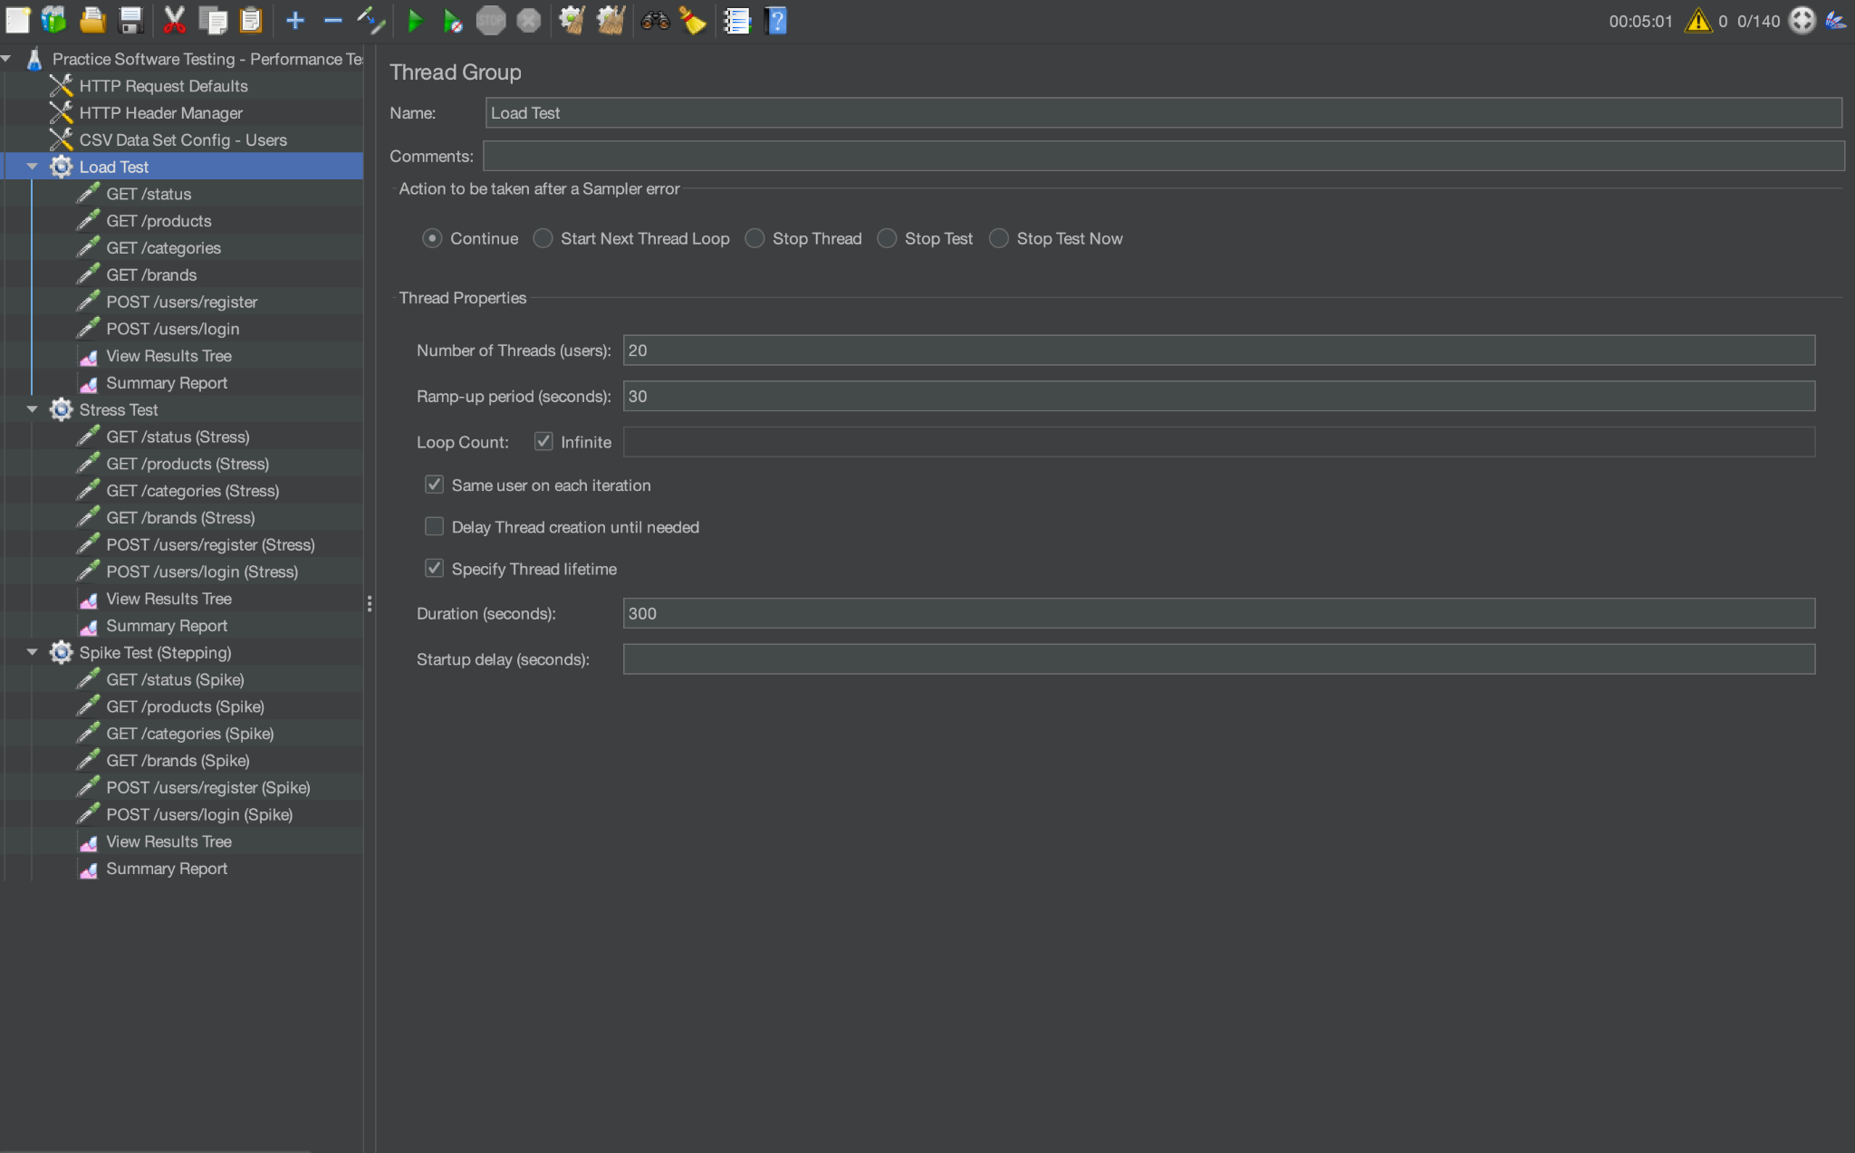
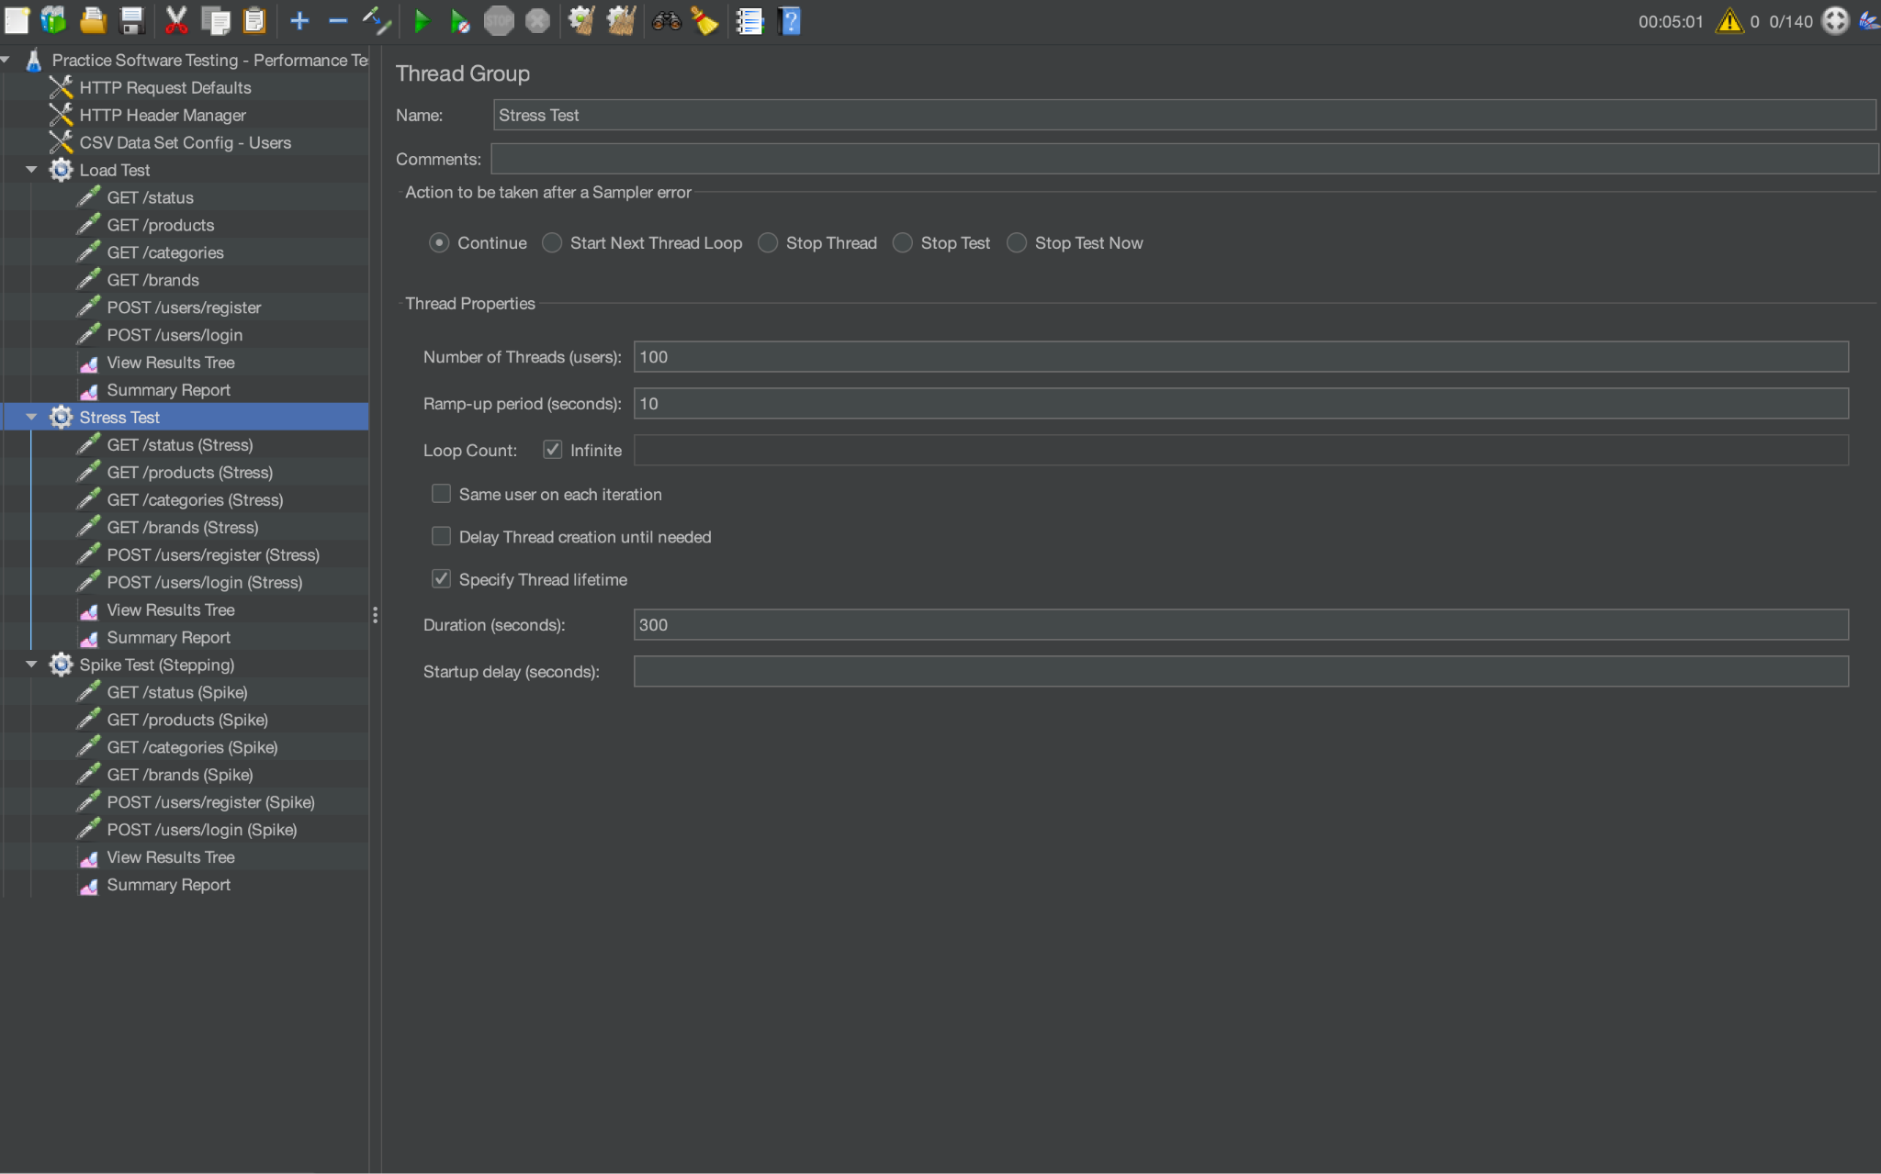
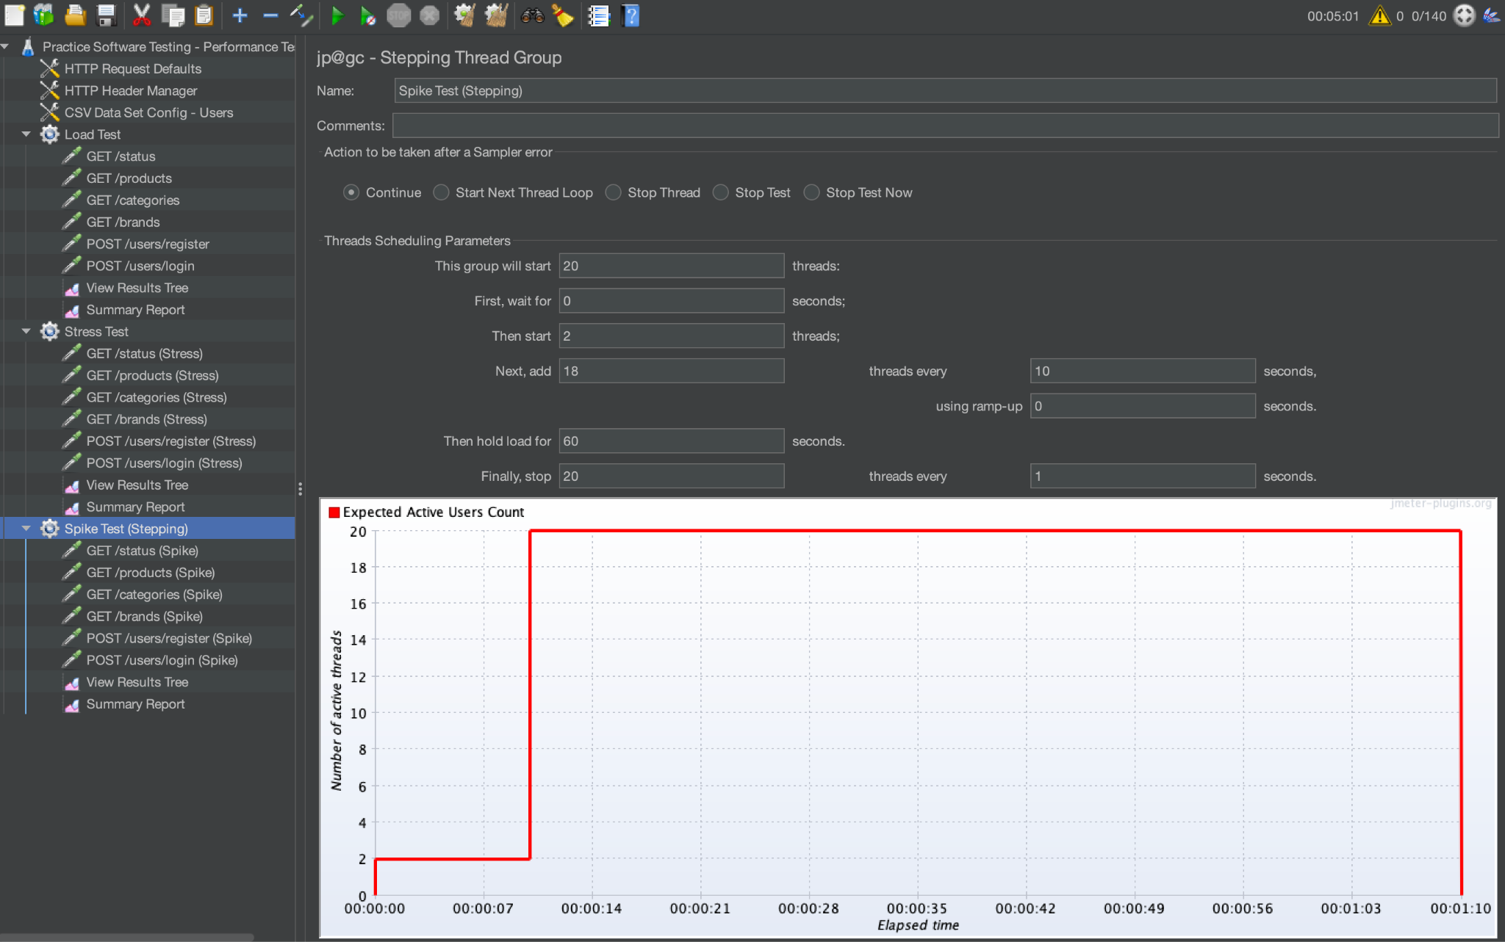

4.2. K6

4.2.1 What is K6
- k6 is an open-source, modern load testing tool designed primarily for performance and reliability testing of APIs, microservices, and web applications. Developed by LoadImpact (now Grafana Labs), k6 is built using Go for high performance and uses JavaScript as its scripting language, making it both fast and developer-friendly.
- Unlike traditional GUI-based tools, k6 is a CLI-driven, code-oriented testing tool. Test scenarios are written as JavaScript scripts, allowing teams to version, review, and maintain performance tests just like any other part of their codebase. This design makes k6 ideal for DevOps, CI/CD pipelines, and cloud-native environments.
- k6 is highly efficient and capable of generating significant load even on a single machine. It emphasizes metrics, automation, and modern development workflows, offering seamless integration with visualization tools such as Grafana, Prometheus, and InfluxDB.

4.2.2 K6 Features
- Performance & Load Testing: k6 is designed to test the performance and scalability of APIs and backend systems. It supports different types of tests such as load testing, stress testing, spike testing, and soak testing, making it suitable for evaluating system behavior under various levels of pressure.
- Scriptable Test Scenarios (JavaScript-Based): k6 uses JavaScript for test development, allowing teams to create flexible, dynamic, and maintainable test scripts. This scripting approach enables complex logic, parameterization, custom workflows, and integration with other developer tools.
- High Efficiency & Low Resource Usage: Built with Go, k6 is lightweight and extremely fast. It consumes fewer resources compared to traditional Java-based tools, enabling higher virtual user counts on a single machine without requiring distributed setups.
- CLI and Automation-Friendly: k6 runs from the command line and integrates easily into CI/CD pipelines such as GitHub Actions, GitLab CI, Jenkins, and Azure DevOps. This supports continuous testing practices and automated performance validation in software delivery pipelines.
- Protocol Support: While focused primarily on modern web technologies, k6 supports key protocols including:
    - HTTP/HTTPS
    - WebSockets
    - gRPC
    - GraphQL
    - API-based testing
- Built-in Metrics & Observability: k6 provides detailed metrics such as request duration, iteration time, throughput, and error rates. Results can be exported to multiple monitoring systems, including:
    - Grafana
    - Prometheus
    - InfluxDB
    - JSON output
    - k6 Cloud (for advanced dashboards)
  - This makes k6 powerful for analyzing performance trends and bottlenecks.
- Scalable with k6 Cloud: For large or distributed load tests, k6 offers a cloud-based execution service. It allows running tests from multiple geographic locations, scaling to large numbers of virtual users, and generating advanced visualization reports.
- Modular & Extensible: k6 supports custom libraries, extensions, and third-party integrations. Users can import JS modules to organize test logic or extend functionality using the xk6 plugin ecosystem.

4.2.3 Advantages K6
- Developer-friendly: Test scripts are written in JavaScript, easy to integrate in code-based workflows.
- Lightweight and efficient: Designed to use fewer resources, capable of handling high loads on a single machine.
- Modern CLI-based tool: Great for automation and CI/CD pipelines.
- Powerful built-in metrics and output options: Supports JSON, InfluxDB, Grafana, Prometheus, and cloud dashboards.
- Readable and maintainable code: Performance tests behave like regular JS code, ideal for teams using Git.
- First-class CI/CD integration: Runs headless, optimized for pipelines and automation.

4.2.4 Disadvantages K6
- Limited protocol support: Focuses mainly on HTTP/HTTPS, WebSockets, and gRPC; not suitable for FTP, SMTP, JDBC, etc.
- No GUI: Requires scripting knowledge; beginners may find it less intuitive.
- Complex scenarios may require extra coding: Looping, data handling, and parallel logic need manual implementation.
- Some enterprise features require k6 Cloud: Advanced visualization, distributed testing, and collaboration features are paid.

4.2.5 Implement scenario

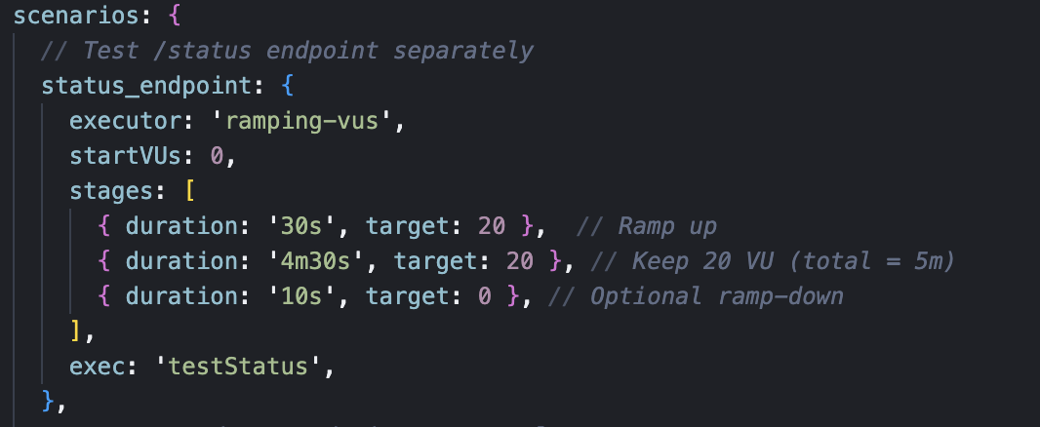

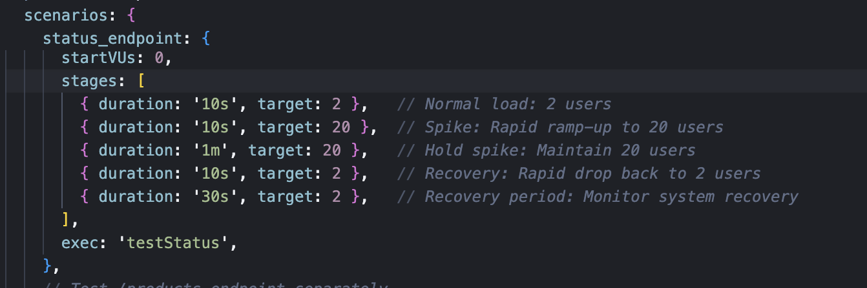
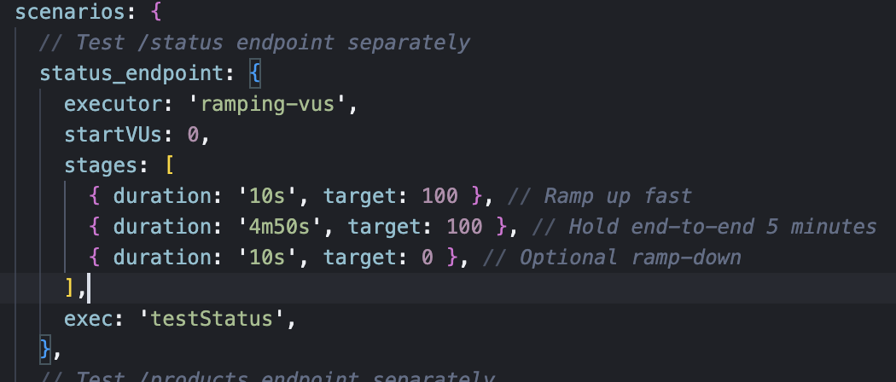

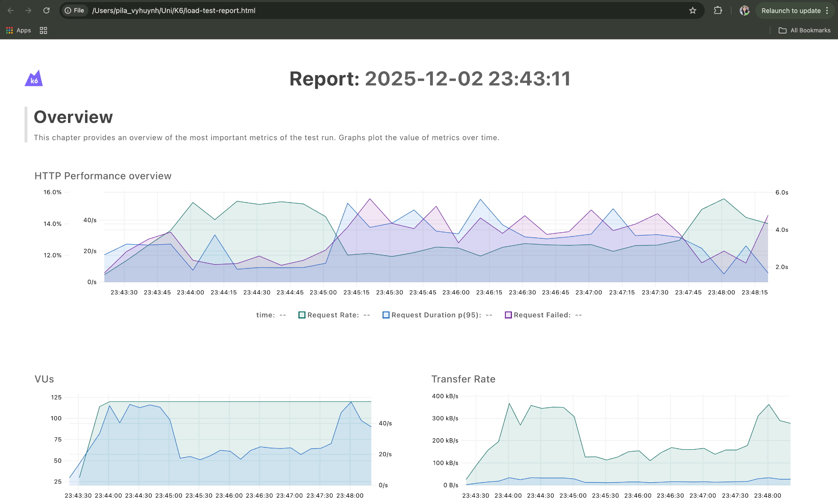

V. Reference

https://www.opentext.com/what-is/performance-testing

https://www.testdevlab.com/blog/what-is-performance-testing

https://www.ibm.com/think/topics/performance-testing

https://www.geeksforgeeks.org/java/apache-jmeter-an-introduction/

https://grafana.com/docs/k6/latest/

